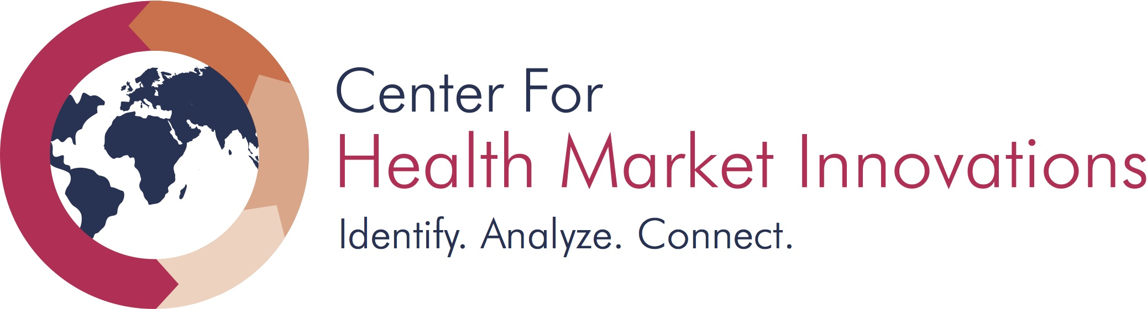
Center for Health Market Innovation’s Learning Exchange
Application
Summary of program: CHMI’s Learning Exchange will provide funding of up to $8,000 USD to successful applicants to facilitate learning partnerships. A Learning Exchange is an engagement between two or more organizations that decide to share knowledge around a particular need or business practice. Partners may be based in the same geography or in different countries; at least one program must be based in West Africa, and both programs need to be based in Sub-Saharan Africa. Because peer-to-peer exchanges are customized to address an organization’s particular and current need, they can be limited in scope to what is necessary to catalyze institutional change.
Definitions for terms used in this application:
Center for Health Market Innovations: The Center for Health Market Innovations (CHMI) promotes programs, policies, and practices that make quality health care delivered by private organizations affordable and accessible to the world’s poor. Managed by Results for Development, CHMI works through regional partners around the world. Details on more than 1,300 innovative health enterprises, nonprofits, public-private partnerships, and policies can be found online at HealthMarketInnovations.org. Organizations applying to participate in CHMI’s Learning Exchange should have a CHMI profile that is complete and up-to-date by the time they submit an application.*
Lead partner: A “lead partner” is a healthcare organization profiled by CHMI that will develop the application for CHMI’s Learning Exchange and be responsible for disbursing funds to other partnering organizations. The “lead” partner can be the “learner” in a traditional “mentor-mentee” relationship; or, the lead partner and knowledge partners can represent similar organizations that may offer complementary skills, expertise, and ability to learn from one another. Lead partners should contact potential knowledge partners through CHMI or through other channels to solicit their agreement to apply for CHMI’s Learning Exchange. Please contact chmilearningexchange@r4d.org if you require assistance in contacting programs through our website.
Knowledge partner: An organization that works with a lead partner to exchange knowledge through activities specified in this application. Knowledge partner(s) should agree to participate with a lead partner prior to being named in an application for CHMI’s Learning Exchange.
++++
*The Center for Health Market Innovations profiles healthcare programs that serve the poor in low- and middle-income countries. Most programs profiled by CHMI involve the private (non-state) sector.

APPLICATION FORM

- Eligibility

- Are both programs located in Sub-Saharan Africa? YES or NO
- Is one or both programs located in West Africa? YES or NO
- Are one or both programs profiled on the CHMI database? YES or NO
- Are the programs profiled on CHMI “gold” programs, in accordance with the CHMI Plus system? YES or NO

If you answered NO or are unsure about the answer to these questions, please email Cynthia Charchi at chmilearningexchange@r4d.org. BEFORE submitting an application.
- Applicant information and profile
Please submit the following information for each partner. Lead partners may apply to work with one or more knowledge partners. Please submit basic information (the boxes below) about each organization that wishes to work together. Note that contact information is not posted on CHMI’s program profiles, but website visitors may contact organizations through the site. We kindly request that all CHMI profiles be updated before your application is submitted to reflect the most current nature of your programs work and information.
Lead Partner

Organization Name
Address
Contact person
E-mail address and phone number
Commitment signature from leadership at the organization
Legal status (nonprofit, for-profit, public-private partnership, other)
Countries of operation

Mission and Objective (Please limit your response to 150 words)

Number of full time employees
Describe your current programs and partnerships (Please limit your response to 150 words)

Knowledge Partner

Organization Name
Address
Contact person
E-mail address and phone number
Commitment signature from leadership at the organization
Legal status (nonprofit, for-profit, public-private partnership, other)
Countries of operation

Mission and Objective (150 words)

Number of full time employees
Describe your current programs and partnerships (Please limit your response to 150 words)

- Proposal

Identified need (Please limit each response to 200 words)
- What challenge or need do you plan to address with a learning partnership through the CHMI Learning Exchange?
- How long has this been a challenge?
- What have you already done to address this challenge? Is there information or data that exists that provides information about this challenge?

Learning Exchange vs. Other Potential Solutions (Please limit each response to 200 words)
- What other alternatives have you considered using as an organization to solve this challenge?
- Why is a learning exchange the best intervention for helping you solve this challenge? How is it better suited than other types of interventions?

Proposed objectives and activities (Please limit your response to 400 words)
- What are your learning objectives?
- What are the proposed activities to meet those needs?
- Why have you chosen to partner with your proposed knowledge partner(s)?
- How will you implement the activities together?
- Is the chosen learning method cost-effective and realistic?

Incorporating knowledge (Please limit your response to 200 words)
- How will you incorporate and institutionalize any new knowledge gained or new practices learned in your organization?
- What are the potential challenges and risks to the sustainability of these changes/improvements and how do you plan on mitigating these risks?

Measuring impact (Please limit your response to 300 words)
- Describe the intended impact of the learning partnership.
- What are the intermediate outcomes, and how will they be measured?
- What is the likelihood of achieving longer-term changes to improve your business, or scale-up or replicate a particular aspect of your program?
- How many people does your organization currently serve, and what proportion of these beneficiaries will likely benefit from the learning exchange?

Consideration for additional opportunities
As part of the Learning Exchange application review process, CHMI will also select a small portion of successful applications for participation in an additional learning collaborative opportunity. If chosen for this opportunity, both the lead and knowledge partner will be sponsored to attend an 2-3 day in-person collaborative meeting in West Africa where they will work with other participating programs, CHMI, and Solina Health. Programs will be selected for this opportunity through a combination of the strength of their application and their fit with other applicants. Your ability or willingness to participate in the additional collaborative will NOT impact the decision making process for the Learning Exchange Application.
Would you like to be considered for this additional opportunity? YES or NO
- Work Plan and Budget
Please submit a work plan and budget in the space below or as attachments in Word or Excel format.
- Describe the key activities, members involved from each organization, and schedule for implementation over the six-month learning exchange (December 2016 to May 2017). All activities must be completed by May 31, 2017.
- Submit a detailed budget, including a breakdown by activity and partner.

- Describe the key activities, members involved from each organization, and schedule for implementation over the next six-month learning exchange (December 2016 to May 2017)). Funding will be disbursed in the first week of December 2016. and all activities must be completed by May 31, 2017. Final reports will be due June 15, 2017.

Action Items  We plan to: | Timeline
 | December | January | February

- Submit a proposed budget for this learning activity, breaking it up by line items such as: staff time/wages, travel to partner country, hiring a consultant, printing/material costs, purchasing new equipment etc. Funding may be used for staff time to work on this activity, travel and meeting costs, operational costs to collaboration (i.e. internet and phone costs), and funding for implementation of new ideas.

PROJECT EXPENSES  (Please provide details) | TOTAL BUDGET

TOTALS

The Center for Health Market Innovations will consider the following countries as being located in West Africa, in accordance with the United Nations statistical categorization of countries: Benin, Burkina Faso, Cape Verde, Cote d’Ivoire, Gambia, Ghana, Guinea, Guinea-Bissau, Liberia, Mali, Mauritania, Niger, Nigeria, Saint Helena, Senegal, Sierra Leone, and Togo. Please note that activities and application materials will be conducted in English.
The Center for Health Market Innovations will consider the following countries as being located in West Africa, in accordance with the United Nations statistical categorization of countries: Benin, Burkina Faso, Cape Verde, Cote d’Ivoire, Gambia, Ghana, Guinea, Guinea-Bissau, Liberia, Mali, Mauritania, Niger, Nigeria, Saint Helena, Senegal, Sierra Leone, and Togo. Please note that activities and application materials will be conducted in English.
For more information about CHMI Plus, please see here.

